Lab 6

Procedure: Capacitors in Parallel:
- Measure the capacitance of individual capacitors and record the reading in data table 1.
- Connect capacitors in parallel
- Measure the equivalent capacitance and record in data table 1.
- Leave the parallel arrangement intact and discharge the capacitors by shorting them 1
at a time.
- Use multimeter to make sure they are fully discharge.
- Connect parallel combination with a dc source.
- DO NOT touch the capacitor leads while measuring as you may discharge the capacitors. Measure and record the potential differences across C1 and C2 respectively. Record the values in data table 1.
- Measure the potential difference across the combination and record in data table 1.
- Using the measured values of voltage and capacitances, find the individual charges and charge of parallel arrangement. Record this in data table 1.
- Using measured values of capacitances, find the energy stored in each capacitor and the energy stored in the combination. Record these values in data table 1.
- Calculate the theoretical equivalent capacitance. Record this in worksheet.
- Calculate the percent error between theoretical and measured values.
- Calculate total theoretical charge. Note it on worksheet.
- Calculate the percent error in measured and calculated values and record on worksheet.

Worksheet

Procedure A: Capacitors in Parallel

 | C1 (Larger Capacitance) | C2 (Smaller Capacitance) | Cp
Cmeas (µF) | 98.3 uF | 54 uF | 152.3 uF
ΔV (v) | 5V | 5V | 5V
Qcalc (µC) | 250 C | 500 C | 750 C
Ecalc (µJ) | 1875 j | 625 j | 1250 j
Parallel Combination of Capacitors on Multisim
Found Voltage.
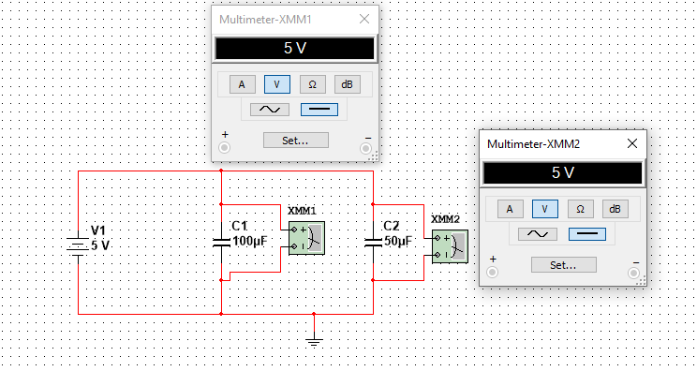

Calculate the theoretical equivalent capacitance for the two capacitors in parallel.
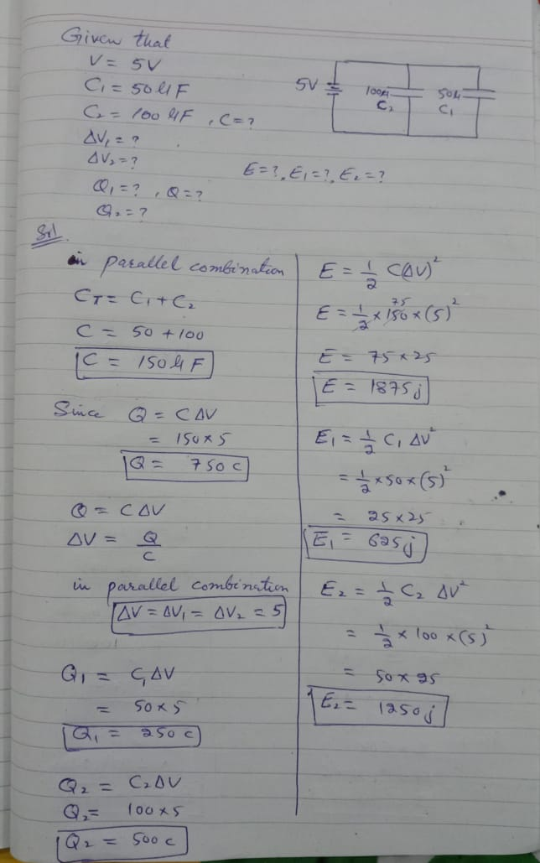

What is the percent difference between your measured equivalent capacitance and the theoretical value of the equivalent capacitance?

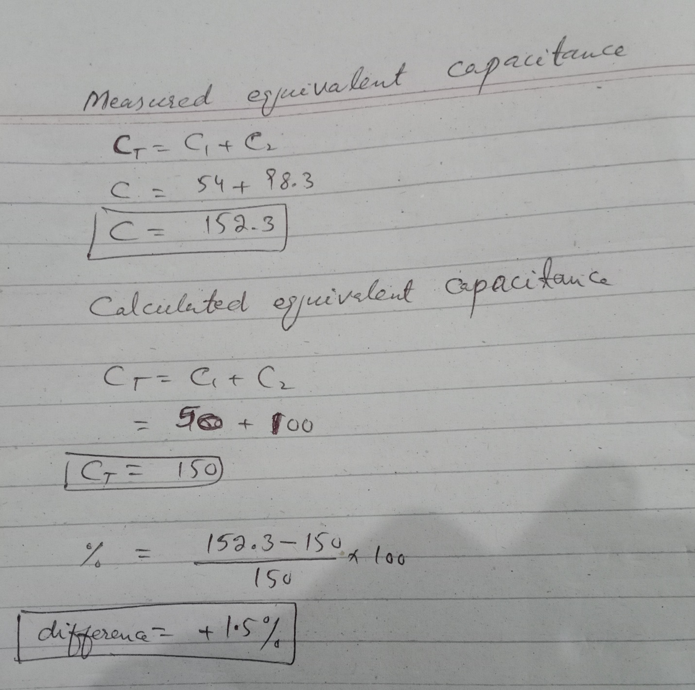

Are the theoretical and calculated values in close agreement? (Consider your percent difference exactly as you have entered it.
Ans: Yes, the theoretical and calculated values are very close, there is only 1.5% more capacitance in measured values than calculated values.

